**UNEMPLOYMENT RATE IN INDIA DURING COVID-19**

**Introduction:**

The COVID-19 pandemic shook up everything, including jobs in India. This abstract looks closely at why people lost jobs during this time. It's like untangling a messy ball of yarn to see the bigger picture. We're not just looking at numbers; we're hearing stories from real people too. From big cities to small villages, we're exploring how different folks dealt with losing work. We're also talking about how being a man or a woman, or where you live, can affect your chances of finding a job .The main sufferers of this lockdown are the informal sector employees as the majority of them started losing jobs since construction works were closed. With no capital, thousands of people deserted cities, marching to their homelands for several hundreds of miles away in the absence of government transportation, which showed their intensity of anguish. This paper aims to delineate the impact of COVID-19 on unemployment in our study area. . As we think about bouncing back, this abstract suggests we need to help out those hit hardest and find ways to make things better for everyone..

### **NEED FOR THE STUDY:-**

* + - The study is focused on the impact on unemployment.
    - Social Impact Asssessment
    - Health and well-being
    - Global comparison

### **SCOPE OF STUDY:-**

* + - The study helps to have a practical exposure in this specific field.

The study helps the respondents to disclose their opinion and view above the increase in unemployment

**Problem Statement:**

"During the COVID-19 pandemic, India has witnessed a significant rise in unemployment, posing serious challenges to its economy and social fabric. With businesses shutting down, job losses have been rampant across various sectors, leaving millions without work. This study aims to analyze the impact of the pandemic on unemployment in India, examining the key factors contributing to the crisis and proposing strategies to address the issue effectively."Analyzing the dataset to get insights of

1. How Covid-19 affects the employment
2. how far the unemployment rate will go

**Technical Architecture:**



**Pre-Requisites:**

For Completing this project these are some of the pre requisites needed

* A system with minimum 4GB RAM and 256GB Hard Disk
* Good Internet Connection
* Google Drive / Any of the Database Server with Management Studio
* MySQL: <https://www.youtube.com/watch?v=2c2fUOgZMmY>
* Tableau Desktop: <https://www.youtube.com/watch?v=b3pWYyrHQo8>
* Tableau Public Account: <https://public.tableau.com/app/discover>
* Html, CSS or Bootstrap

**Prior-Knowledge:**

To Complete this project, one must understand the below concepts and able to work with the tools

* **Data Visualization:** <https://www.youtube.com/watch?v=5gpnZvMSTZs>
* **Uni-Variate, Bi- Variate and Multi-Variate Analysis:** <https://www.youtube.com/watch?v=JG8GRlMjp3c>
* **Chart Types:** <https://www.youtube.com/watch?v=csXmVBw8cdo>
* **Tableau:** <https://www.youtube.com/watch?v=aHaOIvR00So>
* **Business Intelligence**: <https://www.youtube.com/watch?v=Hg8zBJ1DhLQ>

**Project Objectives**

By the end of this project, you will:

* Able to Connect Tableau with different data sources
* Know fundamental concepts and techniques used for Data Visualization.
* Gain a broad understanding about data and different types of charts.
* Have knowledge on developing Visualizations, Dashboards and Story.
* Able to Integrate the developed dashboard and story with the web application

# Project Flow

To accomplish this, we have to complete all the activities listed below,

* Data collection
  + Collect the dataset or create the dataset
* Database /Spread sheet Connection
  + Collect data will be stored into the database or upload into google drive
  + Connect the tableau desktop with google drive option or required database under connectors
* Visualizing and analysing data
  + Understand the Data and the Business Questions
  + Based on the Business questions try to develop the visualizations
  + Develop the Dashboard
  + Develop the Story board
* Publishing to the Tableau public
  + Developed Visualizations, Dashboard and story will be published to Tableau public Account.
  + Once it is published, we will get the shareable links
* Web Application Integration
  + Develop a web application using HTML, CSS or Using Bootstrap
  + Integrate the Visualizations, Dashboard and Story with the Web Application

**Milestone 1: Data Collection**

Data collection is the process of gathering and measuring information on variables of interest, in an established systematic fashion that enables one to answer stated research questions, test hypotheses, and evaluate outcomes and generate insights from the data.

Activity 1: Downloading the dataset

Please use the link to download the dataset:

<https://www.kaggle.com/datasets/gokulrajkmv/unemployment-in-india?select=Unemployment+in+India.csv>

**Milestone 2: Working with Dataset**

Activity 1: Understand the data

These dataset contains the unemployment rate of all the states in india

Fields include

* States = states in India
* Date = date which the unemployment rate observed
* Frequency = measuring frequency (Monthly)
* Estimated Unemployment Rate (%) = percentage of people unemployed in each States of India
* Estimated Employed = Number of people employed
* Estimated Labour Participation Rate (%) = The labour force participation rate is the portion of the working population in the 16-64 years age group in the economy currently in employment or seeking employment.
* Area = Rural and Urban Area

**Activity 2: Import Dataset into Database and connect Tableau Desktop to Database server.**

Explanation video link:

<https://drive.google.com/file/d/1DNhhEQikCFIMy0hx3lClFcHbTcVGKec8/view?usp=sharing>

**Milestone 4: Data Visualization**

Data visualization is the process of creating graphical representations of data in order to help people understand and explore the information. The goal of data visualization is to make complex data sets more accessible, intuitive, and easier to interpret. By using visual elements such as charts, graphs, and maps, data visualizations can help people quickly identify patterns, trends, and outliers in the data.

**Activity 1:** **Employed rate across each state Analysis :**

This graph illustrates aboutUnemployment Rate in india across each state in percentage.

**Explanation video link:**

<https://drive.google.com/file/d/1OH4wnz42_MvGks5Sp0SiY8WGctkoIQZs/view?usp=sharing>

**Activity 2: Unemployment rate in top 10 states**

This graph illustrates aboutUnemployment Rate in Top 10 States( Bihar has the Highest unemployment Rate as compare to other States

**Explanation video link:** [**https://drive.google.com/file/d/175tHX1YQoqaJ8N1Z6xwZ-fIKIlo5F3No/view?usp=sharing**](https://drive.google.com/file/d/175tHX1YQoqaJ8N1Z6xwZ-fIKIlo5F3No/view?usp=sharing)

**Activity 3: Top 10 labour participation rate by area**

This graph demonstrates the top 10 Labour Participation by Area , In Rural area Maximum Labour participate from Tripura state.

**Explanation video link:** [**https://drive.google.com/file/d/1sBLhjoJKfSBhqQ0cXGdoihCaCG1PaP-m/view?usp=sharing**](https://drive.google.com/file/d/1sBLhjoJKfSBhqQ0cXGdoihCaCG1PaP-m/view?usp=sharing)

**Activity 4: Estimated Employed rate before and after lockdown**

The pie chart explain about top 10 Labour Participation by Area , In Rural area Maximum Labour participate from Tripura state.

**Explanation video link:** <https://drive.google.com/file/d/1dfzaqcf79l7Bm5yZd_RVMs11sYILtZA5/view?usp=sharing>

**Activity 5: Impact of lockdown on unemployment rural and urban area in 2019**

The donut give the complete insights of data, In the year 2019 before lockdown in urban area 27.15% people are unemployed

**Explanation video link:**

<https://drive.google.com/file/d/190K4ncAVO0YbsV4fVKok8gngEPVKRlLU/view?usp=sharing>

**Activity 6: Impact of lockdown on unemployment rural and urban area in 2020**

The donut give the complete insights of data, In the year 2020 after lockdown more than 50 percent people's are unemployed from Urban area.

**Explanation video link:**

<https://drive.google.com/file/d/190K4ncAVO0YbsV4fVKok8gngEPVKRlLU/view?usp=sharing>

**Activity 7: Employment rate in top 10 states**

Estimated Employed in Top 10 states As compare to other states bihar has top estimated employed after lockdown where as least state is chandigarh.

**Explanation video link:**

<https://drive.google.com/file/d/1ooYhhXPpB8IoKDf_EWzGH_nwW9HWspMo/view?usp=sharing>

**Activity 8: Percent Change in unemployment before and after lockdown**

Unemployment rate in india before and aftr lockdown.In 2019 unemployment was less in most of the States. After lockdown unemployment rate was increased due to covid 19.

**Explanation video link:**

<https://drive.google.com/file/d/1ifRxY5jENL3bh3ZXPNnMuE8zK9hawRYK/view?usp=sharing>

**Milestone 5: Dashboard**

Dashboard can be defined as an information management tool that visually tracks, analyses, and displays key performance indicators (KPI), metrics, as well as key data points, allowing you to monitor the current state of your business, department, team, or specific process.

Activity :1- Creating the Dashboard

Once you have created views on different sheets in Tableau, you can pull them into a dashboard.

Explanation video link:

<https://drive.google.com/file/d/1c14zJL6MsAFQIeWVIc6HnpwUKA2h2gnB/view?usp=sharing>

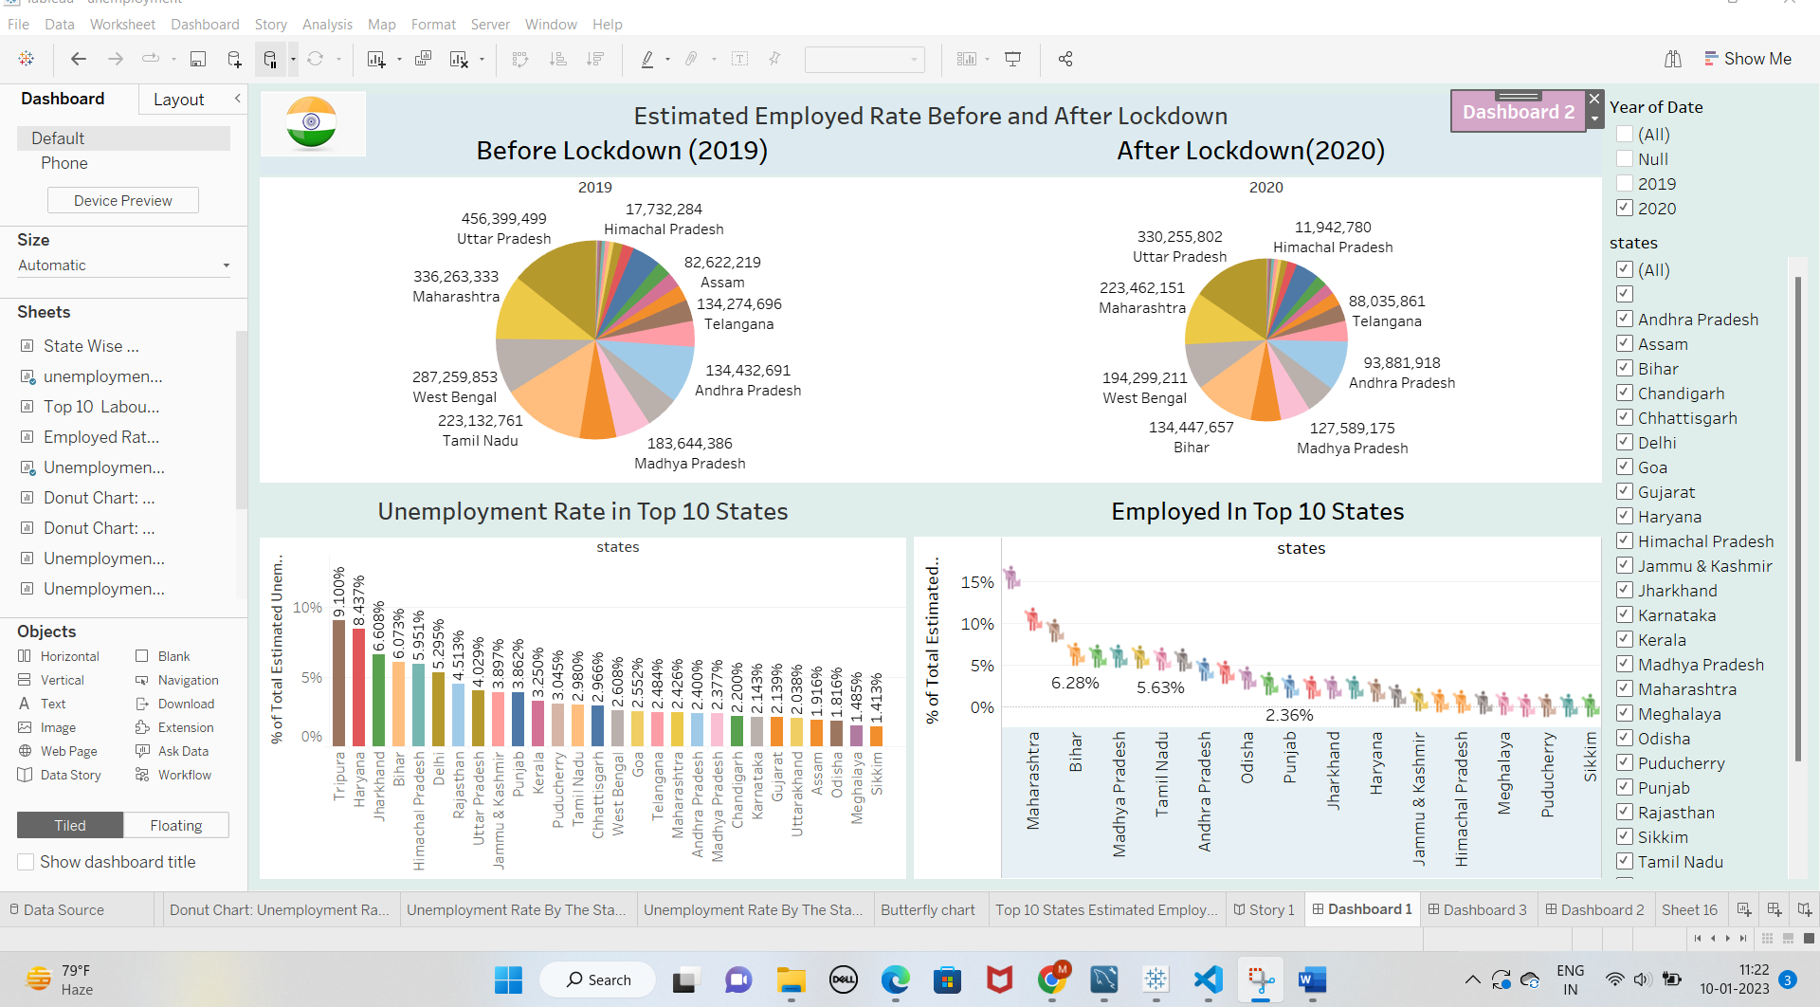

**Milestone 6: Story**

A data story is a way of presenting data and analysis in a narrative format, with the goal of making the information more engaging and easier to understand. A data story typically includes a clear introduction that sets the stage and explains the context for the data, a body that presents the data and analysis in a logical and systematic way, and a conclusion that summarizes the key findings and highlights their implications. Data stories can be told using a variety of mediums, such as reports, presentations, interactive visualizations, and videos.

**Activity:1-Creating the story board**

**Explanation video link:**

**Story Part :**

<https://drive.google.com/file/d/1IFPflpICwyK4wgmAsEuRg3e5NsE-KoUb/view?usp=sharing>

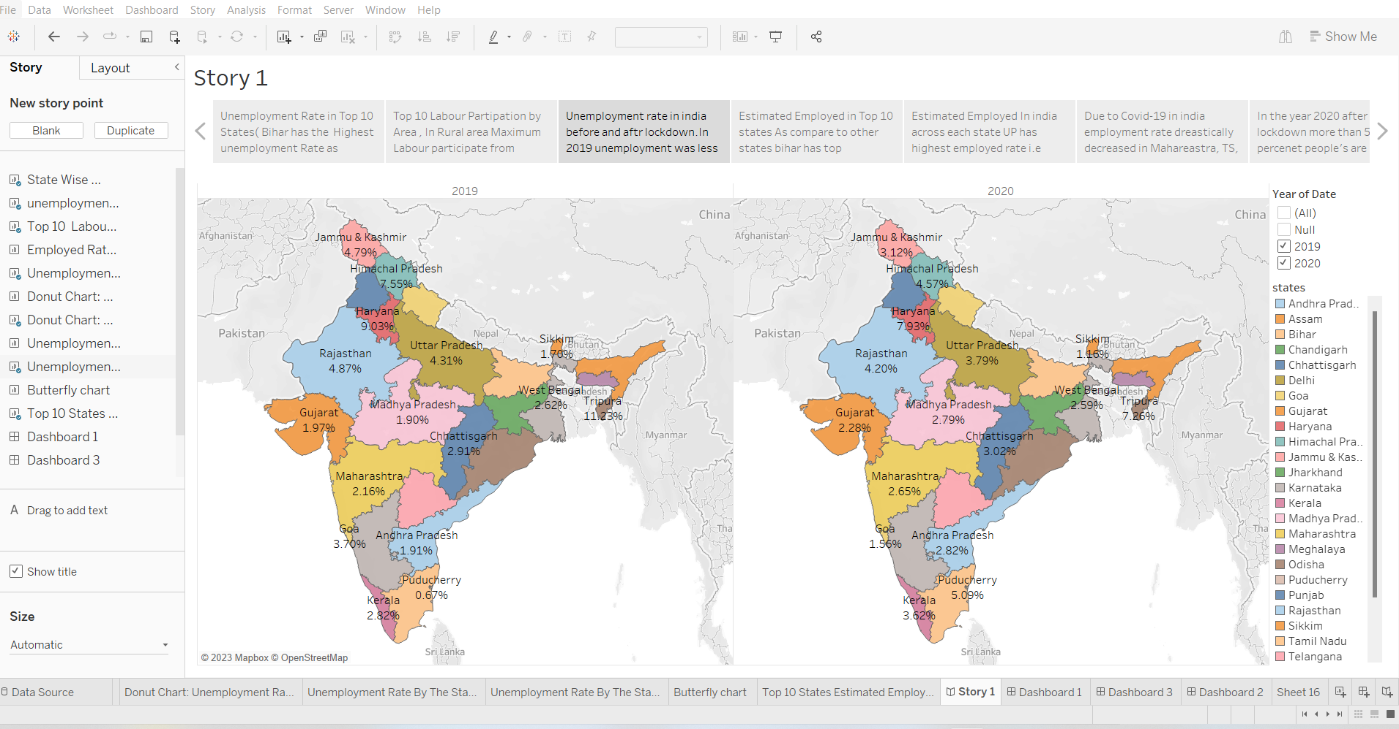

**Milestone 7: Publishing and Web integration**

Publishing helps us to to track and monitor key performance metrics, to communicate results and progress. help a publisher stay informed, make better decisions, and communicate their performance to others.

**Activity 1 : Publishing dashboard and reports to tableau public**

Step 1: Go to Dashboard/story, click on share button on the top ribbon

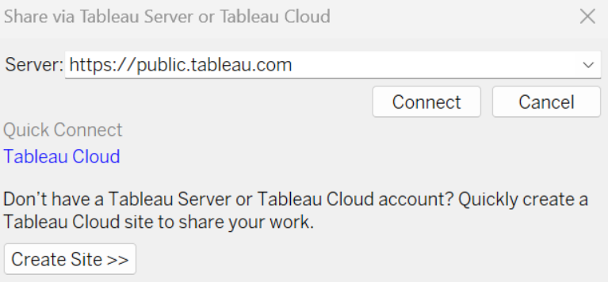

Give the server address of your tableau public account and click on connect.

**Step 2:** Once you click on connect it will ask you for tableau public user name and password

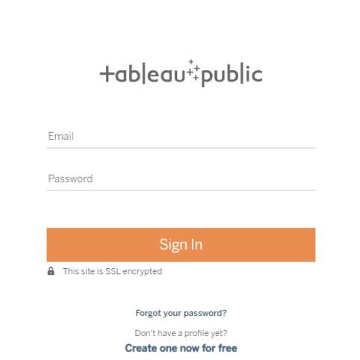

Once you login into your tableau public using the credentials, the particular visualization will be published into tableau public

**Note: While publish the visualization to the public, respective sheet will get published where you click on share option.**

**Activity 2 : Integrating with Web with Embed code**

[**https://drive.google.com/file/d/1F-fkjU9niidfU6OL0ANaT58Rhf0c7k7c/view?usp=share_link**](https://drive.google.com/file/d/1F-fkjU9niidfU6OL0ANaT58Rhf0c7k7c/view?usp=share_link)

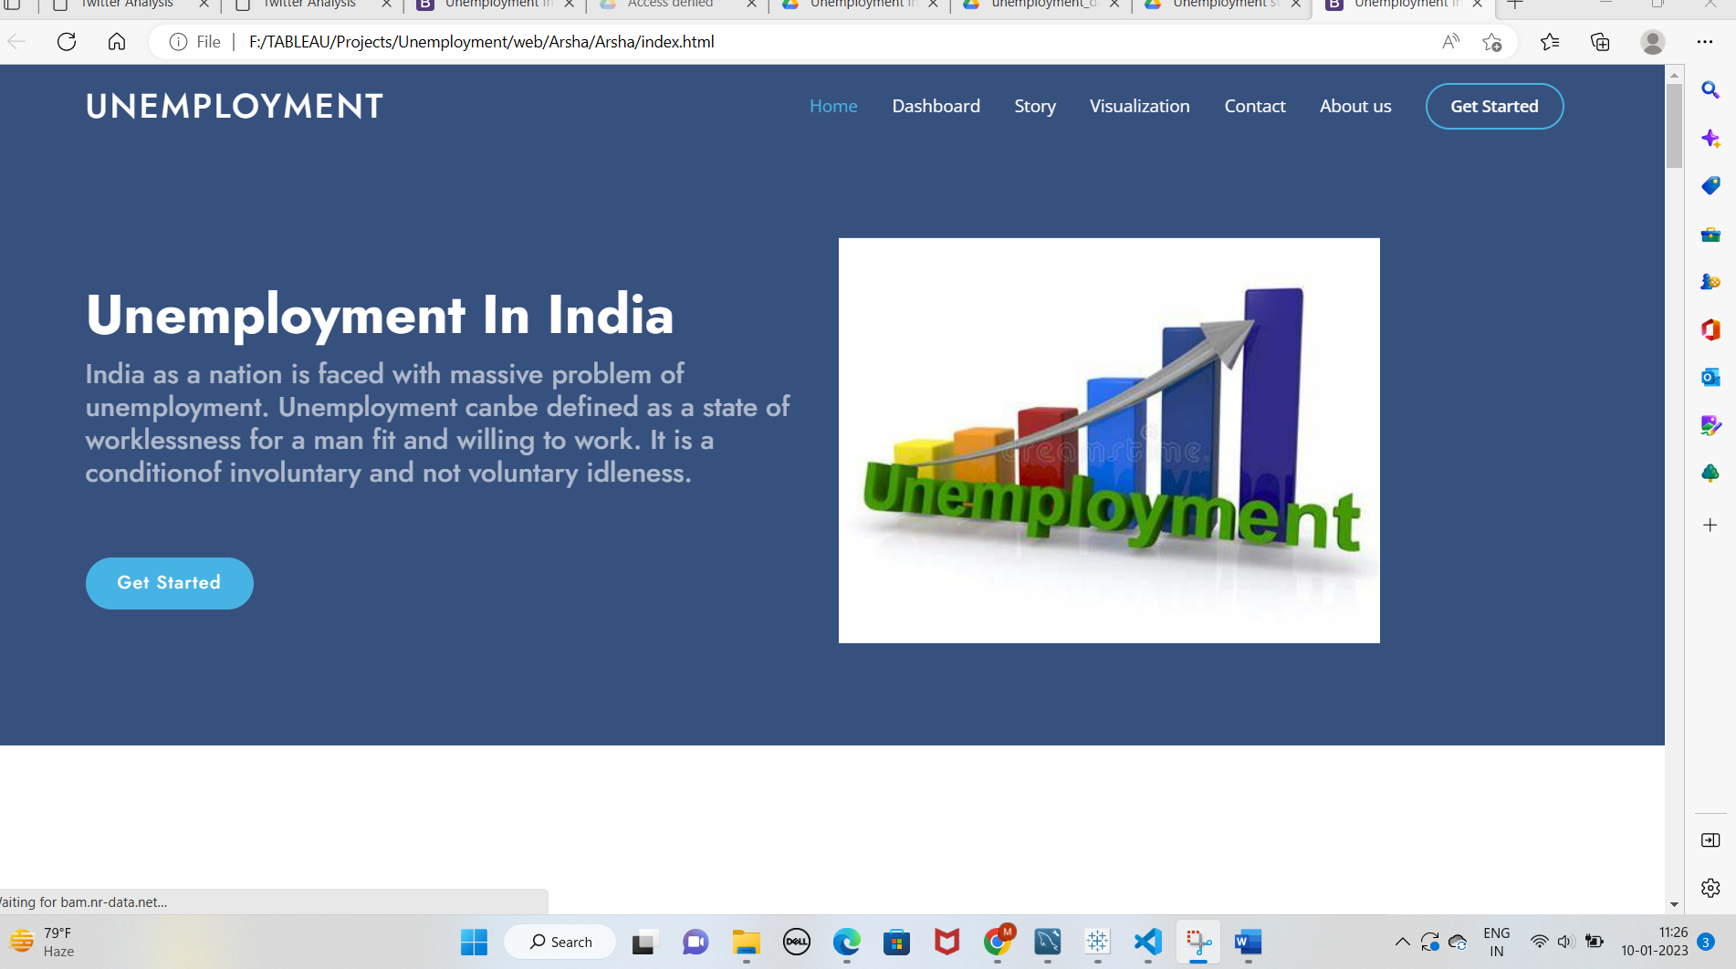

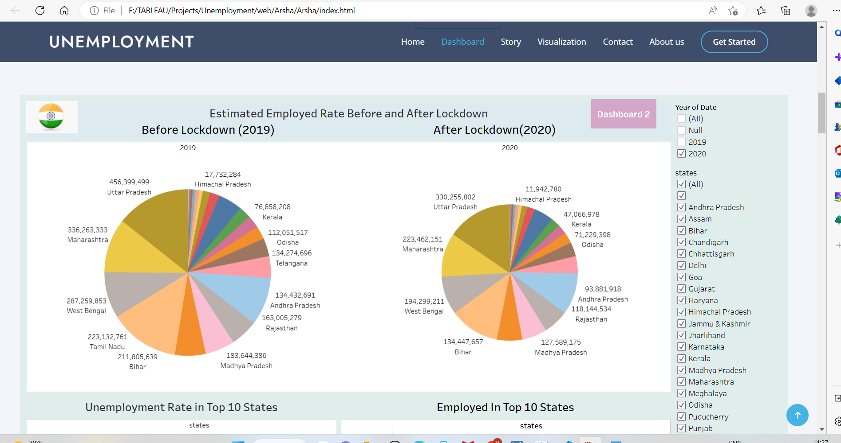

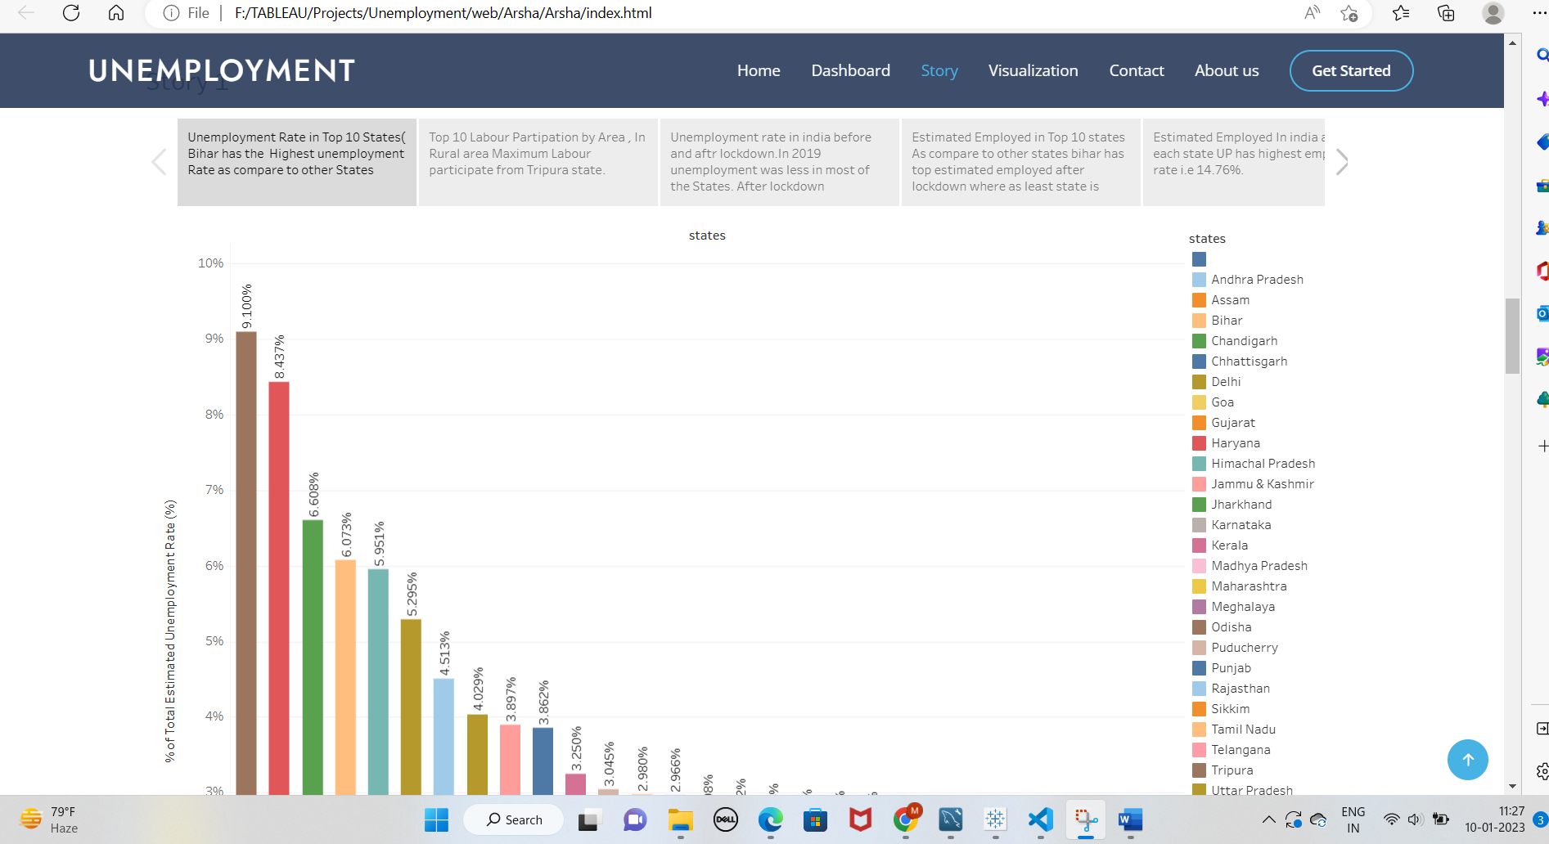

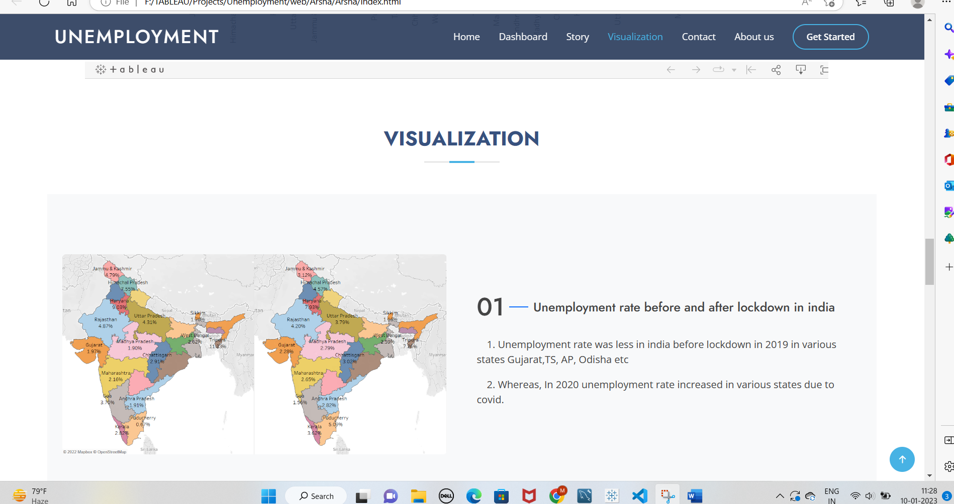

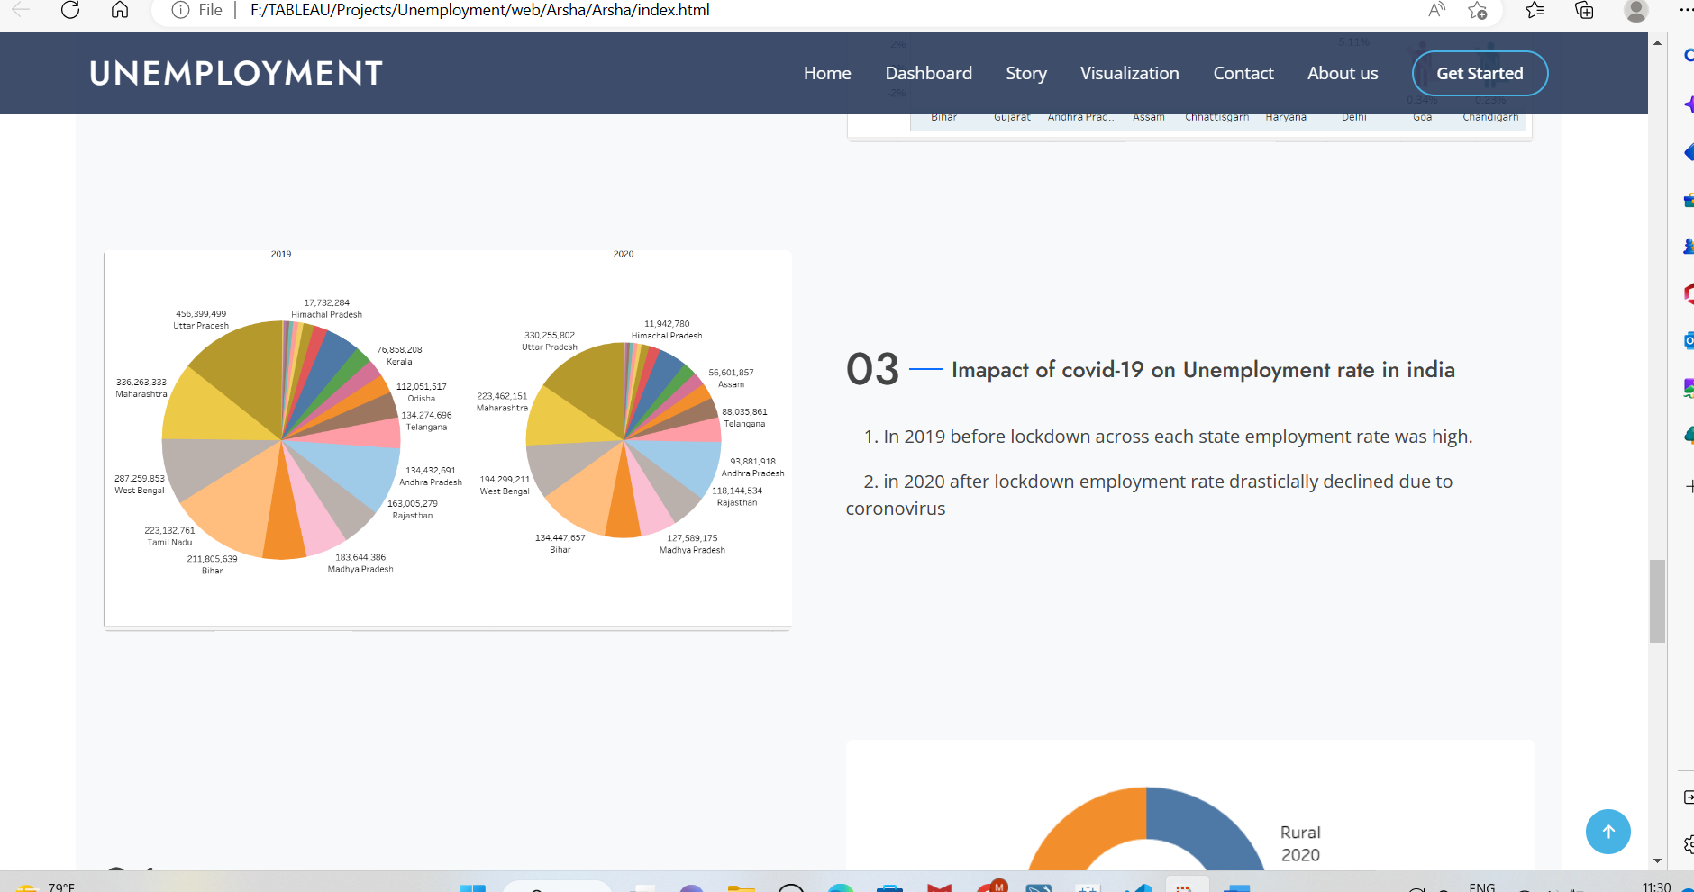

**Conclusion:**

* Due to covid-19 unemployment rate drastically increased in various states in india , mostly impacted states are Bihar, Jharkhand, Haryana, Puducherry, Tripura, etc.
* The rate of unemployment in urban India stands higher at 56.56% as against rural 43.44%.
* In 2019 Estimated employment rate was high before the lockdown. However, Because of the coronavirus change in percent sudden decrease in employment in 2020.

**TEAM MEMBERS**

**1. Gudipati Prudhvi Raj Kashyap – Team Leader**

**2. Gotti Akhila – Team Member**

**3. Surfraj- Team Member**

**TEAM ID - LTVIP2024TMID10547**